**0.Linked List Node**

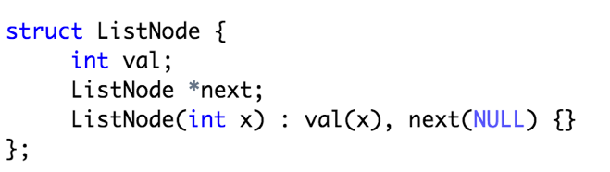

**1.given a single linked list找到中间的元素**

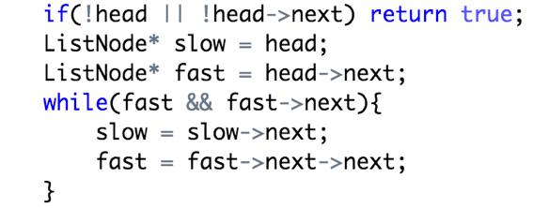

total number is odd, the middle is slow;

total number is even, the first middle number is slow, the second is slow->next;

**2.given a single linked list, 求倒数第n个node的value**

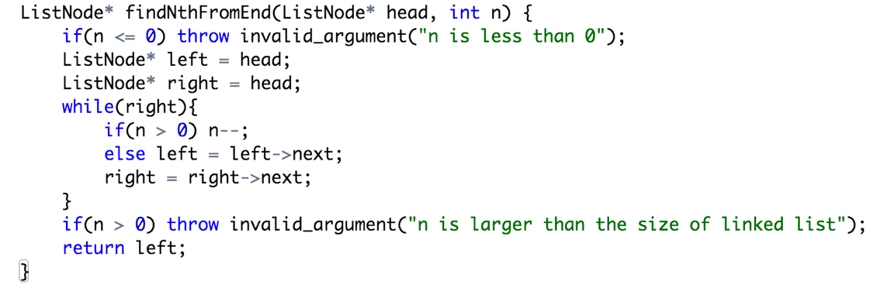

**3.merge two sorted linked list.**

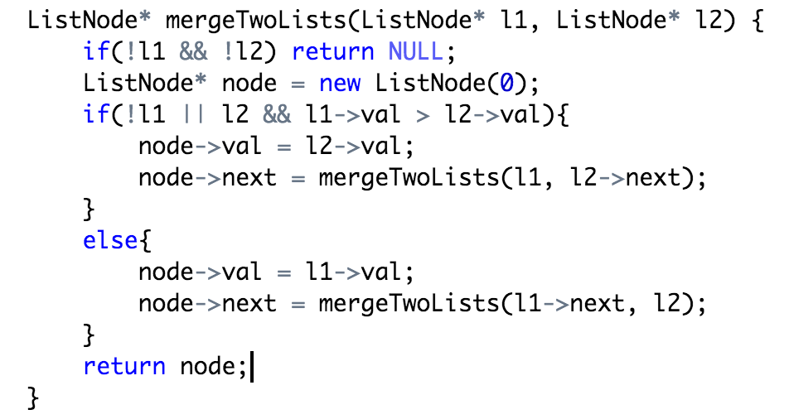

**4.check a cycle in a linked list**

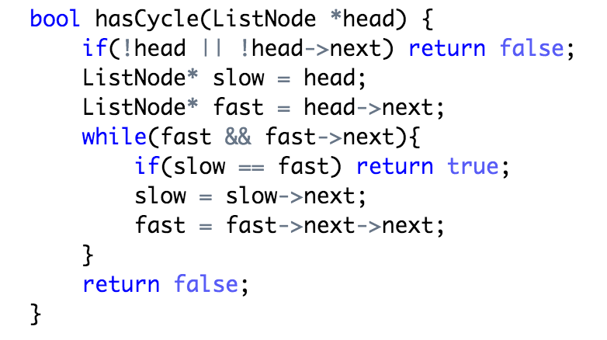

**5. swap nodes in pairs**

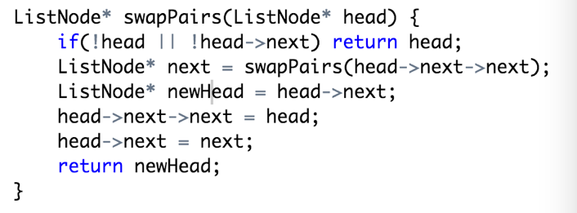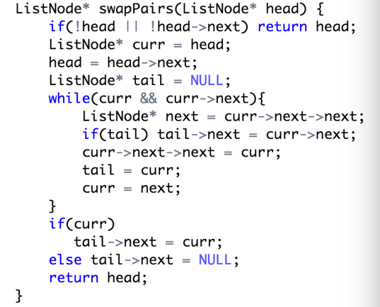

**6.reverse a linked list (如果input 有环，则为invalid)**

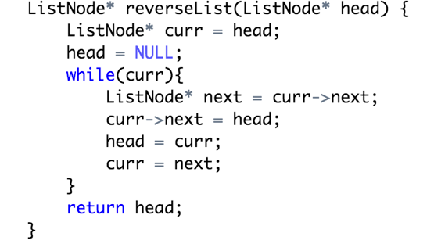

**7.Intersection of two linked lists**

方法1. Unordered_set

方法 2. Make the two linked list same length, look from the back, they will reach the common point at the same time.

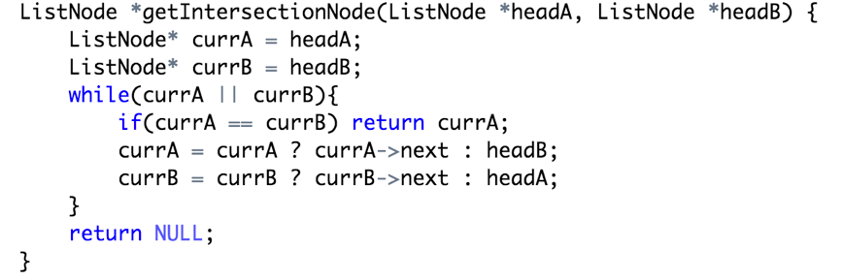

方法3. Double linked list, 如果有交叉那么从其中一条链遍历到交叉点的时候无法回到上一个节点

**8.delete a node in a circular singly linked list.**

**null throw error，if only head return null，head->next == target**

**9.把一个linked list根据even, odd分成两个linked list, 不可创建new node.**

**use two prehead, two pointed, in the end add two NULL tail**

**10.删除一个linked list里重复的节点** Given 1->2->3->3->4->4->5, return 1->2->5.

